**SimpleChat User Guide & FAQ**

Contents[1]

**1. Introduction 2**

**2. Getting Started 2**

2.1 Creating an Account 2

2.2 Logging In 3

**3. Customisation Features & Usage 4**

3.1 Creating your own Chatbot 4

Tips for success: 7

3.2 Updating your chatbot 7

3.3 Uploading a File for context 8

3.4 Removing and Updating File Uploads 9

3.5 Deleting your Chatbot 10

**4. Chatting with a Chatbot 12**

**5. Troubleshooting & FAQs 13**

Q1: I can't log in. What should I do? 13

Q2: My chatbot responses are incorrect. How can I fix this? 14

Q3: Why can’t my chatbot generate images? 14

Q4: Why did my chatbot suddenly stop responding? 14

Q5: How do I delete my account? 14

Q6: Why is my file upload failing? 14

Q7: How do I reset the chatbot conversation? 15

Q8: My account or chatbot disappeared? 15

**6. FAQ Support Chatbot 15**

# 1. Introduction

SimpleChat is an AI-powered chatbot service that helps users interact efficiently with automated responses. This guide will help you get started and troubleshoot common issues. You may also choose to use our chatbot instead to understand how to use our app (Refer to the last section on “FAQ Support Chatbot”.

# 2. Getting Started

## 2.1 Creating an Account

Visit SimpleChat login page.

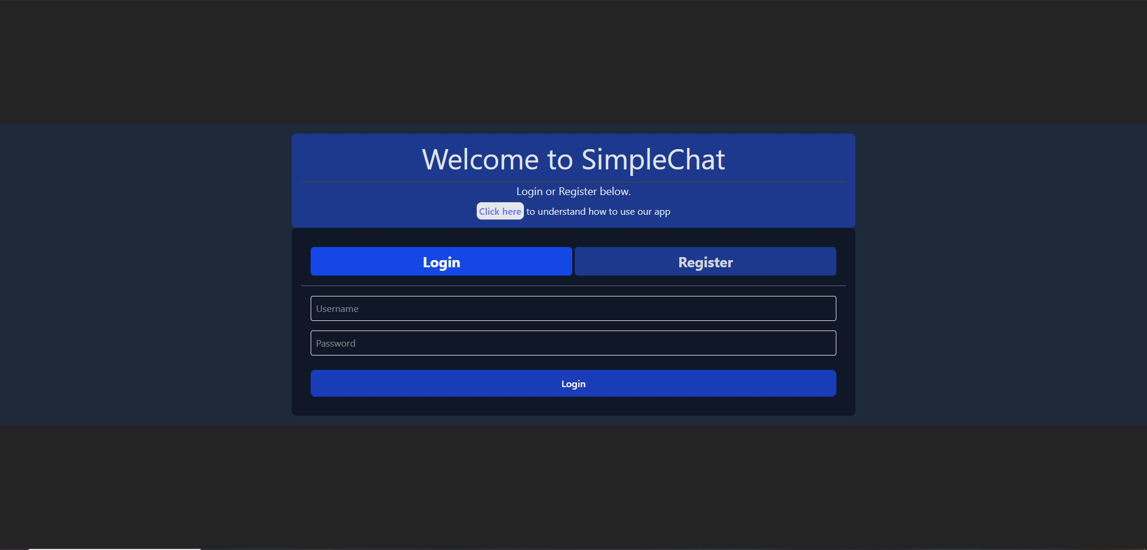

Click on Register.

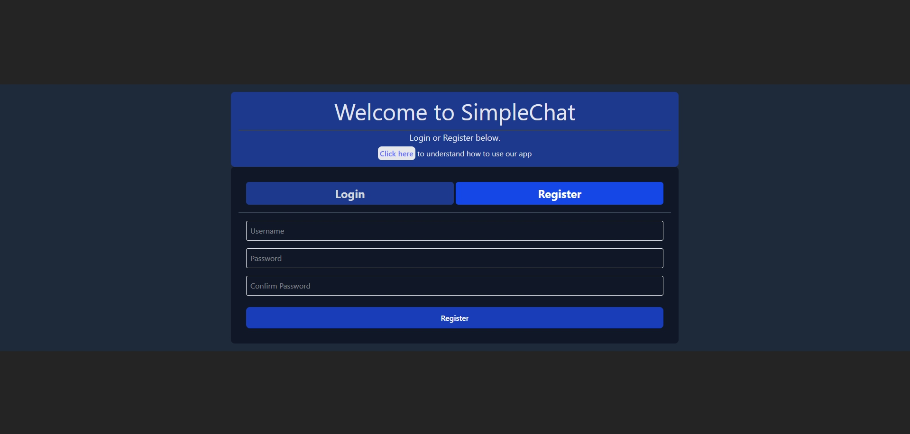

Enter a valid Username and Password.

Click Submit to create an account.

**Note** that we do not offer password reset services. Do write down your username and password somewhere in case you lose it.

## 2.2 Logging In

Go to SimpleChat Login.



Enter your Username and Password.

Click Login.

If login fails, please check that your credentials are correct.

Once logged in, you will be navigated to Dashboard.

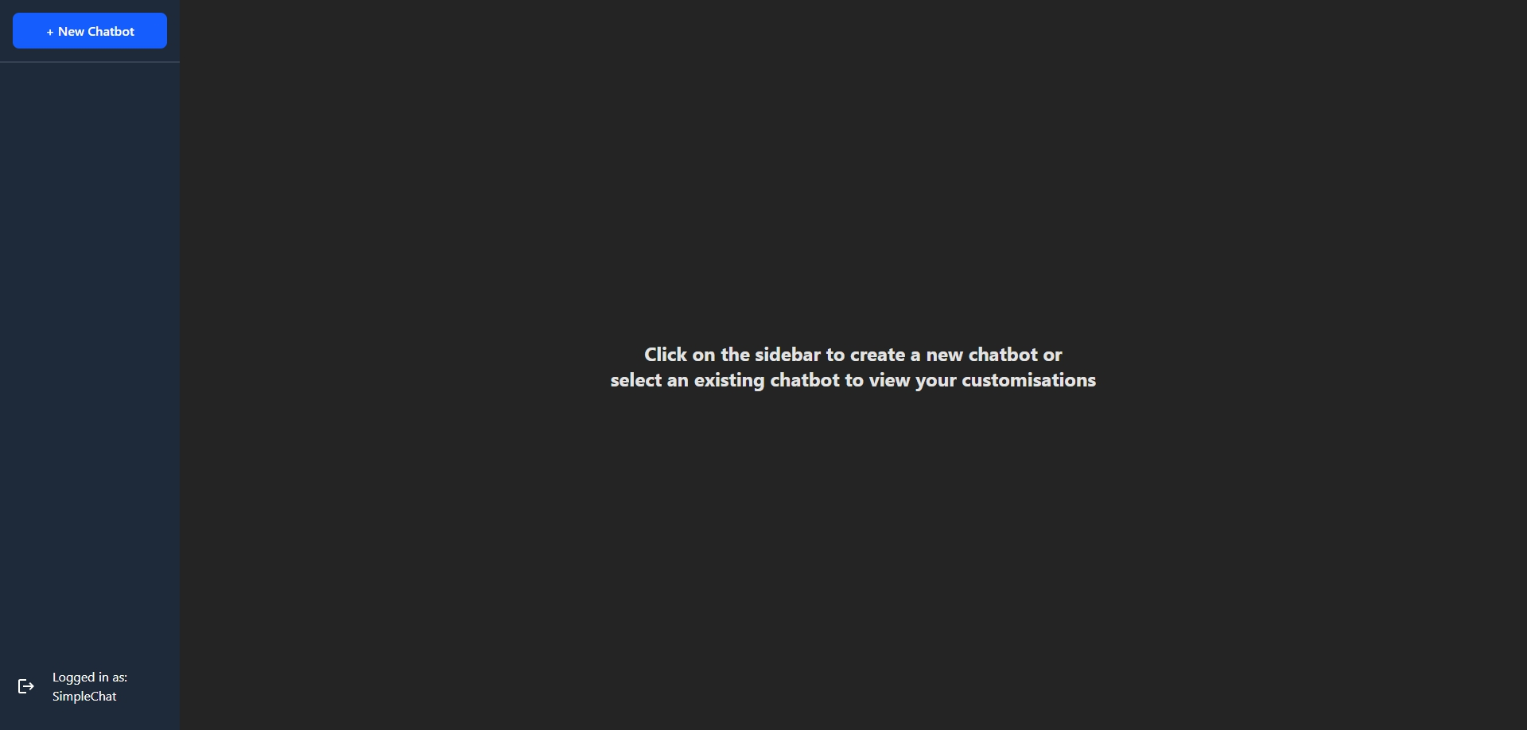

# 3. Customisation Features & Usage

## 3.1 Creating your own Chatbot

You will need your own account to make use of this feature.

After login, you will see this dashboard page.



Click on New Chatbot at the top left corner to see the settings page.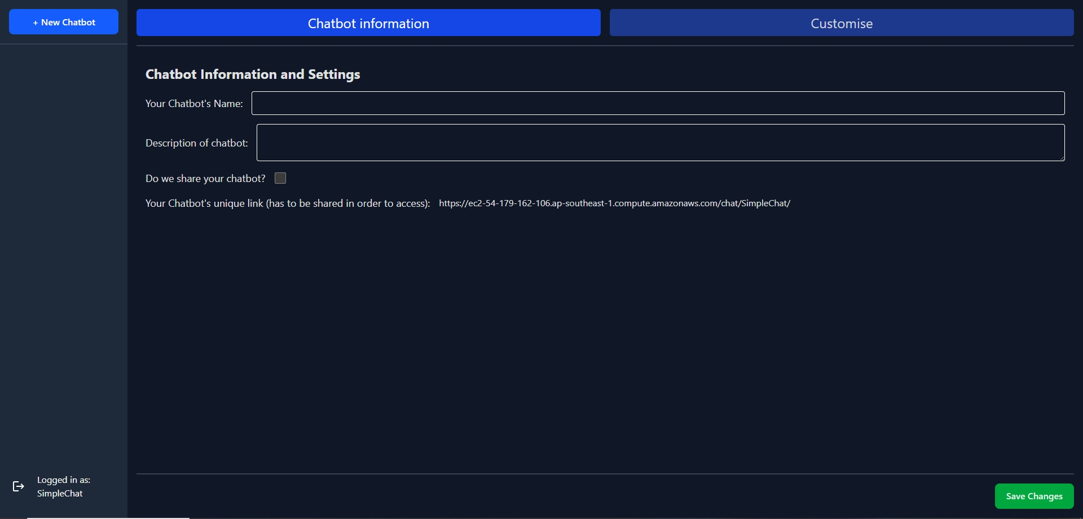

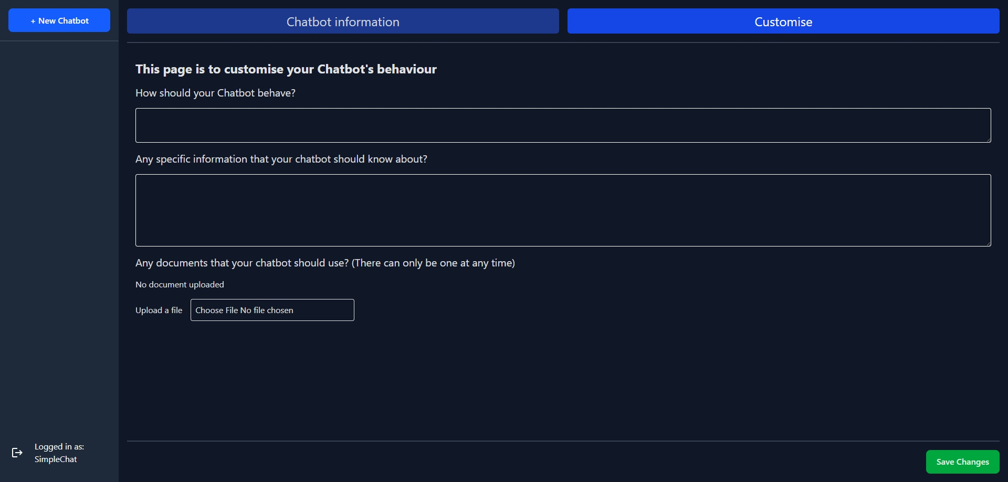

Modify chatbot behavior and context as required.

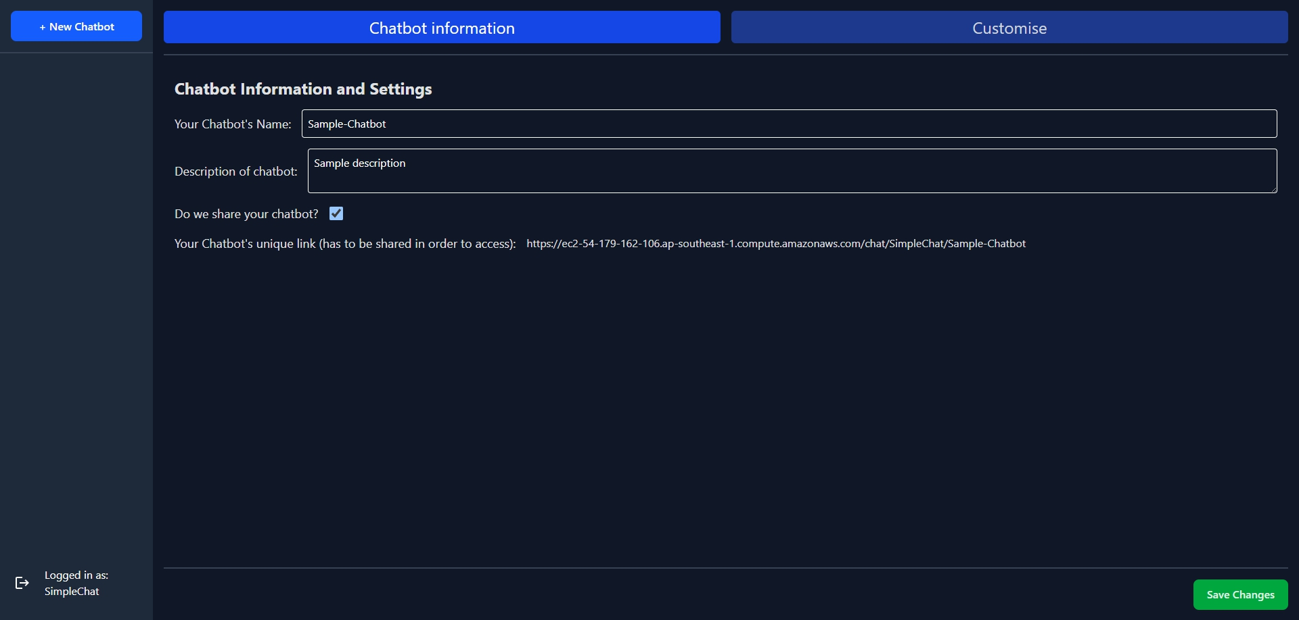

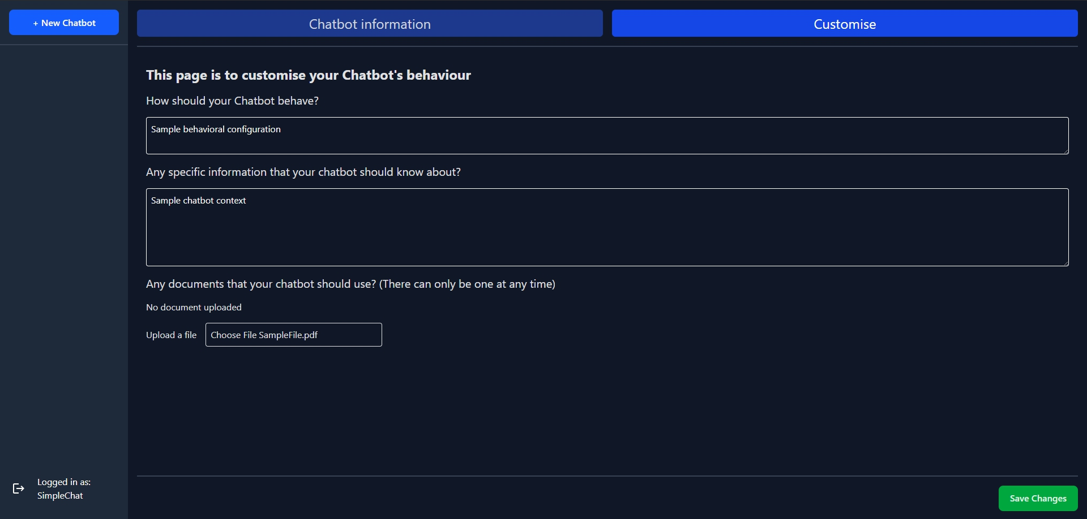

Click Save Changes to apply updates.

**Note** that you will need to save your chatbot settings and check the “Do we share your chatbot?” in order to access your customised chatbot via the link on the “Chatbot information” tab.

### **Tips for success:**

All inputs will be passed to the customised chatbot for it to understand what it is meant to do. You can use these inputs to define or provide

* A persona or role (for a customer service chatbot, for example)
* Output format (Preferring bullet points etc)
* Output style and tone (eg, poetic, formality, or target reading level)
* Rules for the responses (eg, returning answers or code snippets with detailed explanations instead of allowing students to copy)
* Additional context for the prompt (such as specific details about your task)
* **Advanced:** Specifying which language the chatbot should respond in (chatbots may be able respond in the users language, even if your customisations/instructions are written in another language).

## 3.2 Updating your chatbot

You can also update your chatbot if you find that the settings are not satisfactory.

Simply change the information on your dashboard and click on save changes. Any changes will be saved and updated immediately for your users.

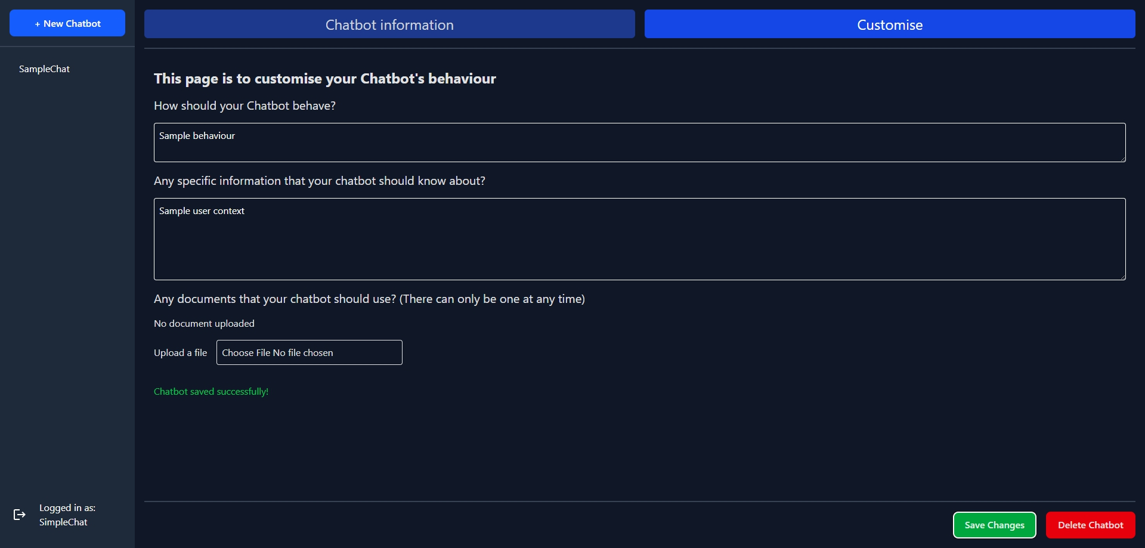

## 3.3 Uploading a File for context

We understand that sometimes it is easier to upload a document that you already have for the chatbot to refer to.

On the chatbot settings “Customise” tab, you may notice a box for uploading files



Click on the Upload a File button and select a file from your device.

Click Save Changes to upload.

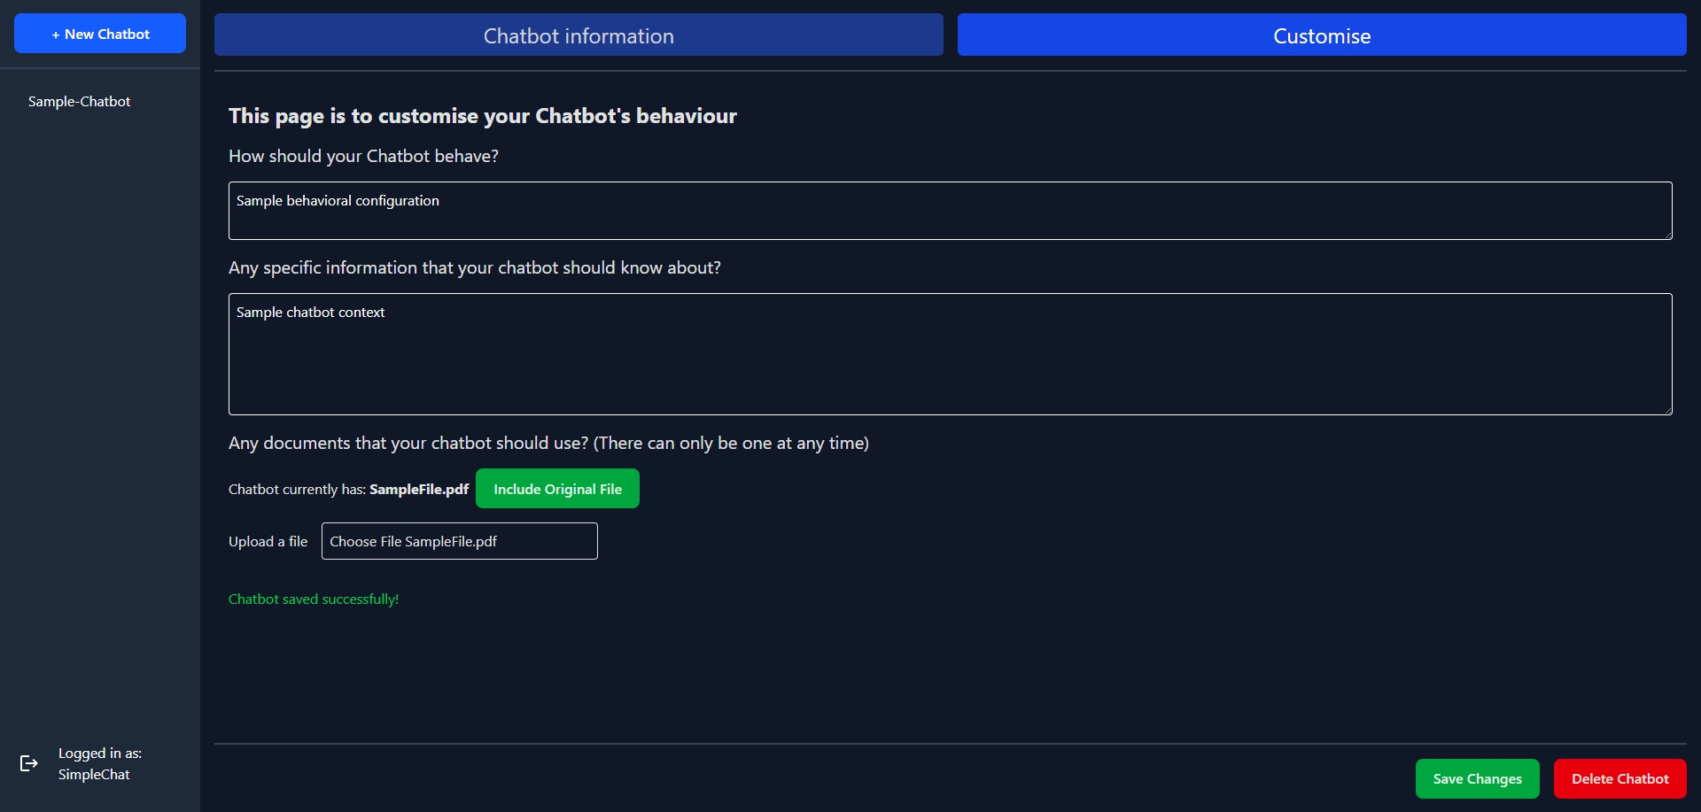

The chatbot will use the uploaded file as a reference for responses.

**Note** that

* You can only upload one file at a time. The file can only be a maximum of 10MB and only pdf, jpg and jpeg file types are allowed.
* Context provided via the text inputs are preferred over files.
* There are slight differences between the text input customisations and the uploaded file. These text inputs are processed before the prompt while the file is injected before your user's prompt.
* This means that text inputs are adhered to over the full user interaction with the model while the file input may not. However, the differences are only noticeable over long chat sessions.

## 3.4 Removing and Updating File Uploads

If you want to remove an uploaded file, you can reselect a new file and click save.

If you do not want a file, you can simply click on the “Include Original File” button to toggle it to exclude before clicking save.



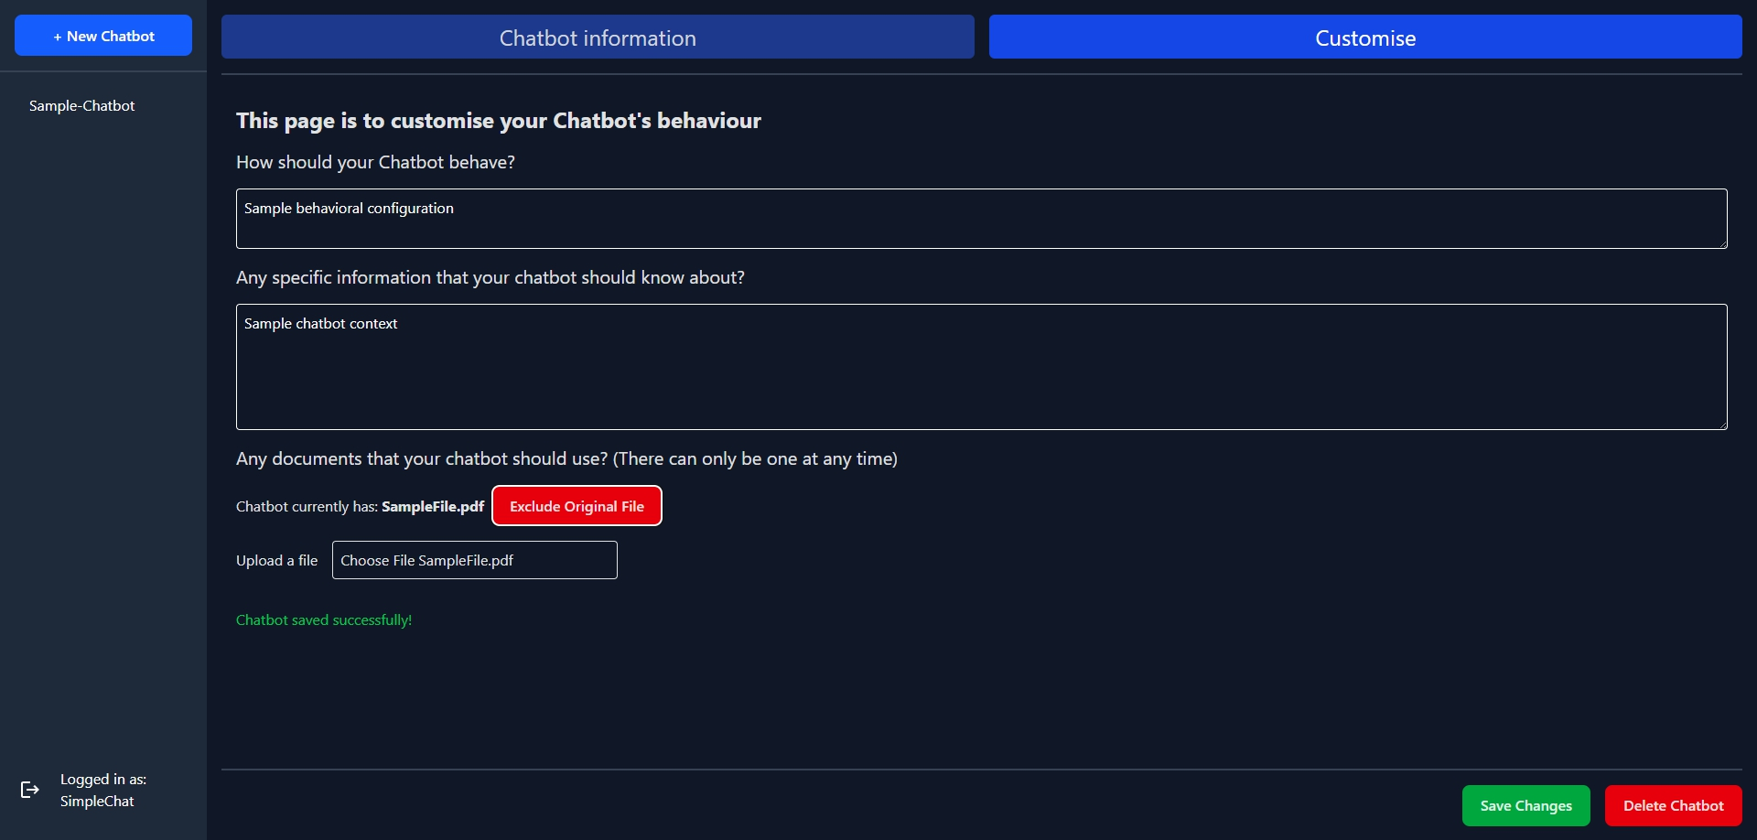

## 3.5 Deleting your Chatbot

If you need to delete your chatbot along with its files, click on the “Delete Chatbot” button.

There will be a confirmation modal before it is deleted permanently.

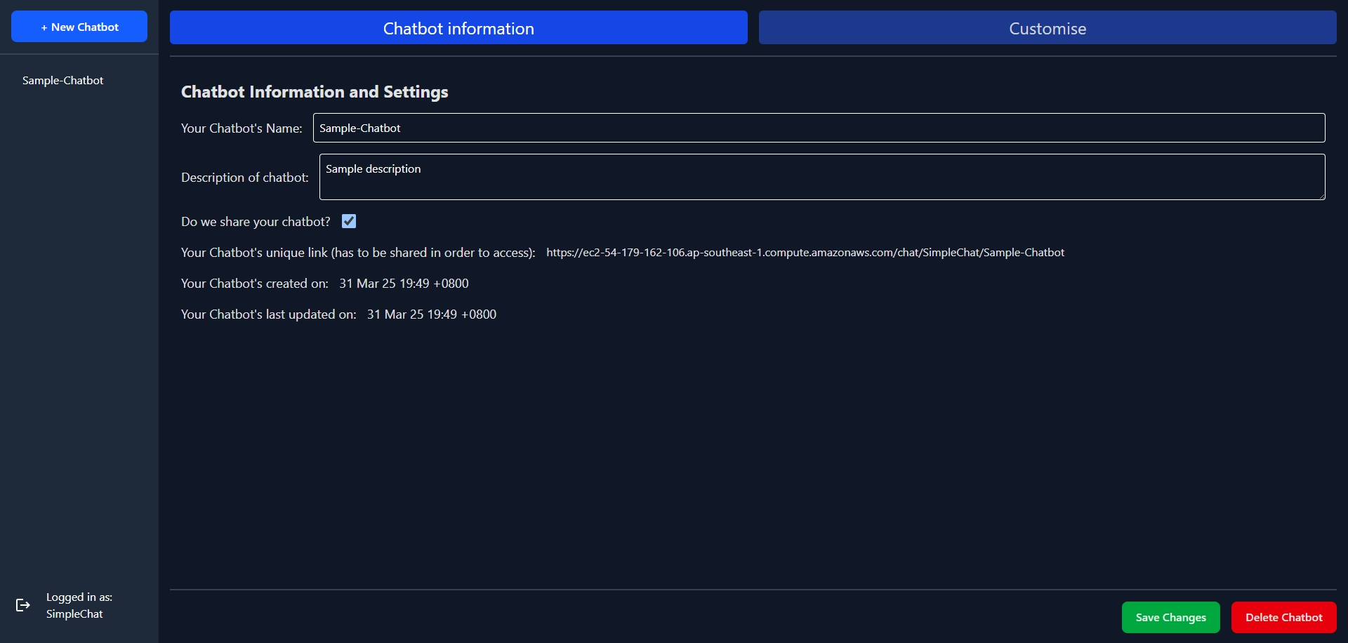

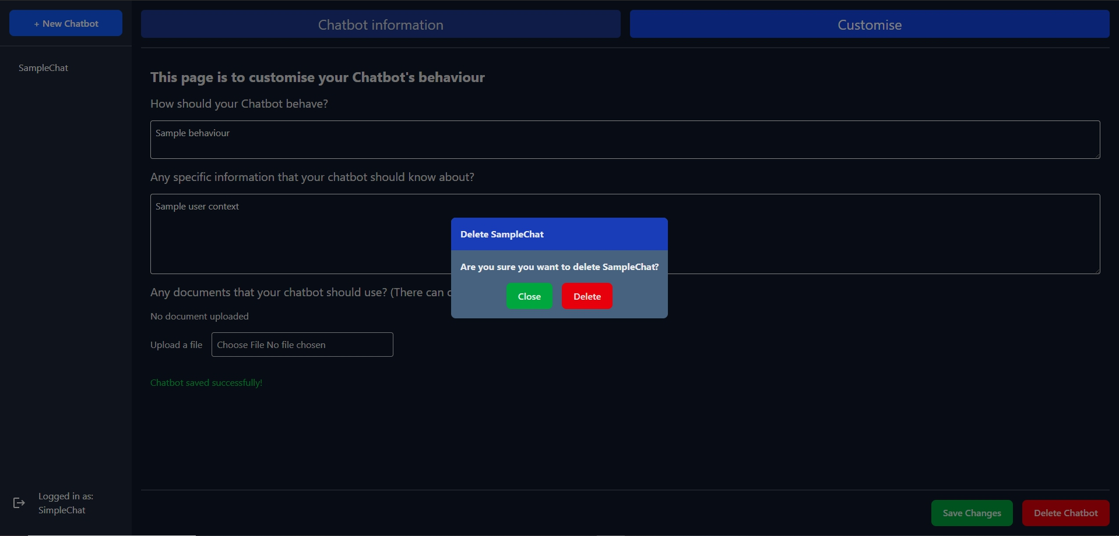

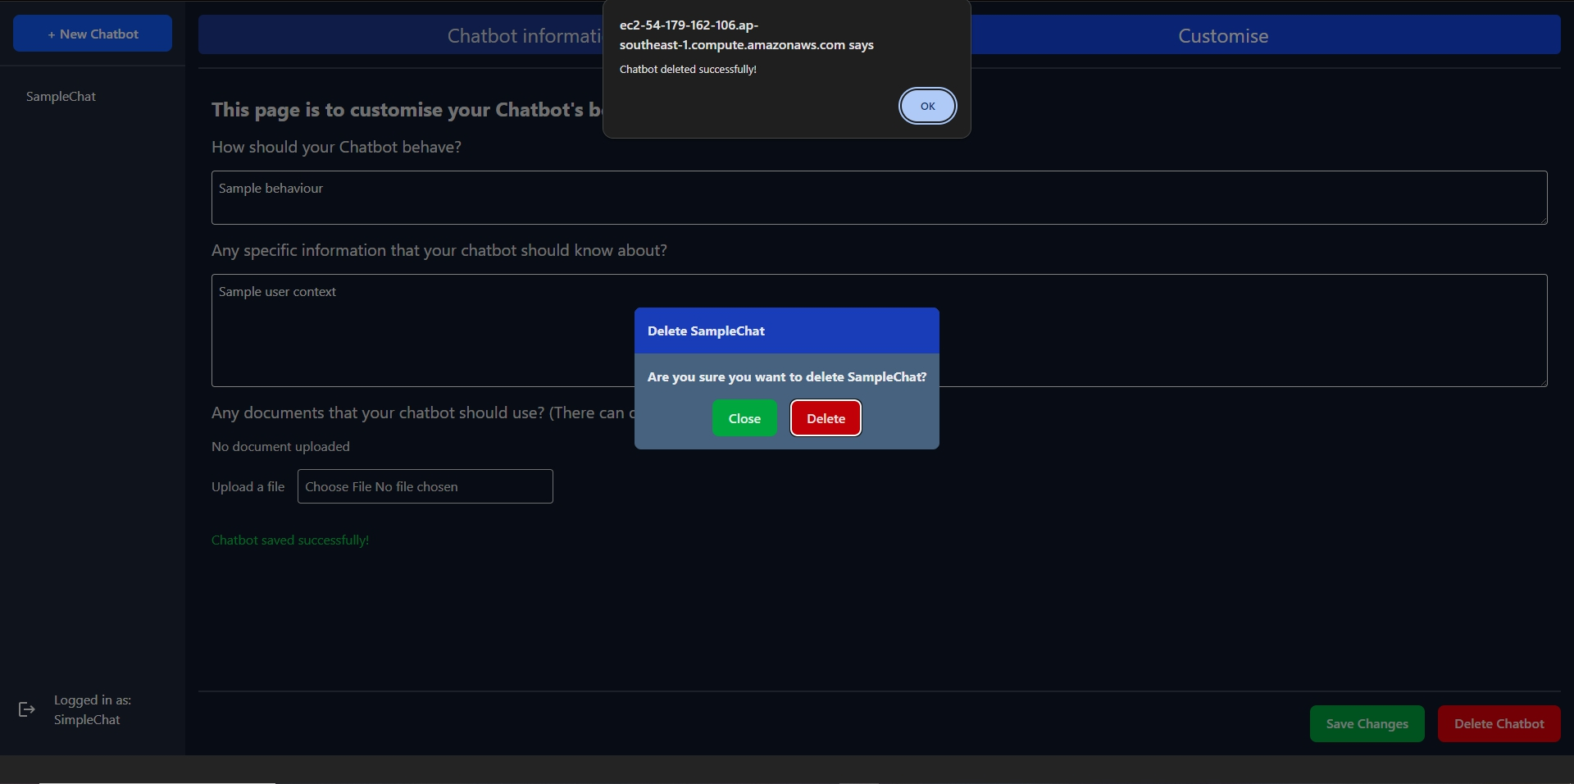

# 4. Chatting with a Chatbot

This feature was made to be similar to other AI chatbot providers.

In order to use this feature, you will need a **link** to the chatbot created by a user (Refer to section 3.1 for more information). However, you **do not** need an account to chat with a chatbot.

When you reach the link provided, you will see our conversations page similar to below.

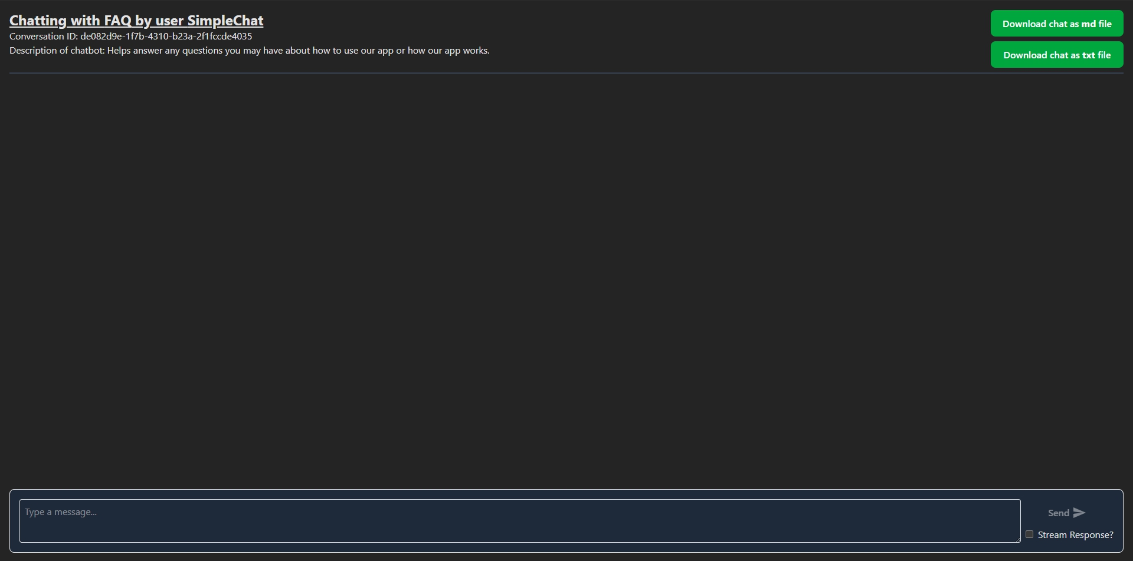

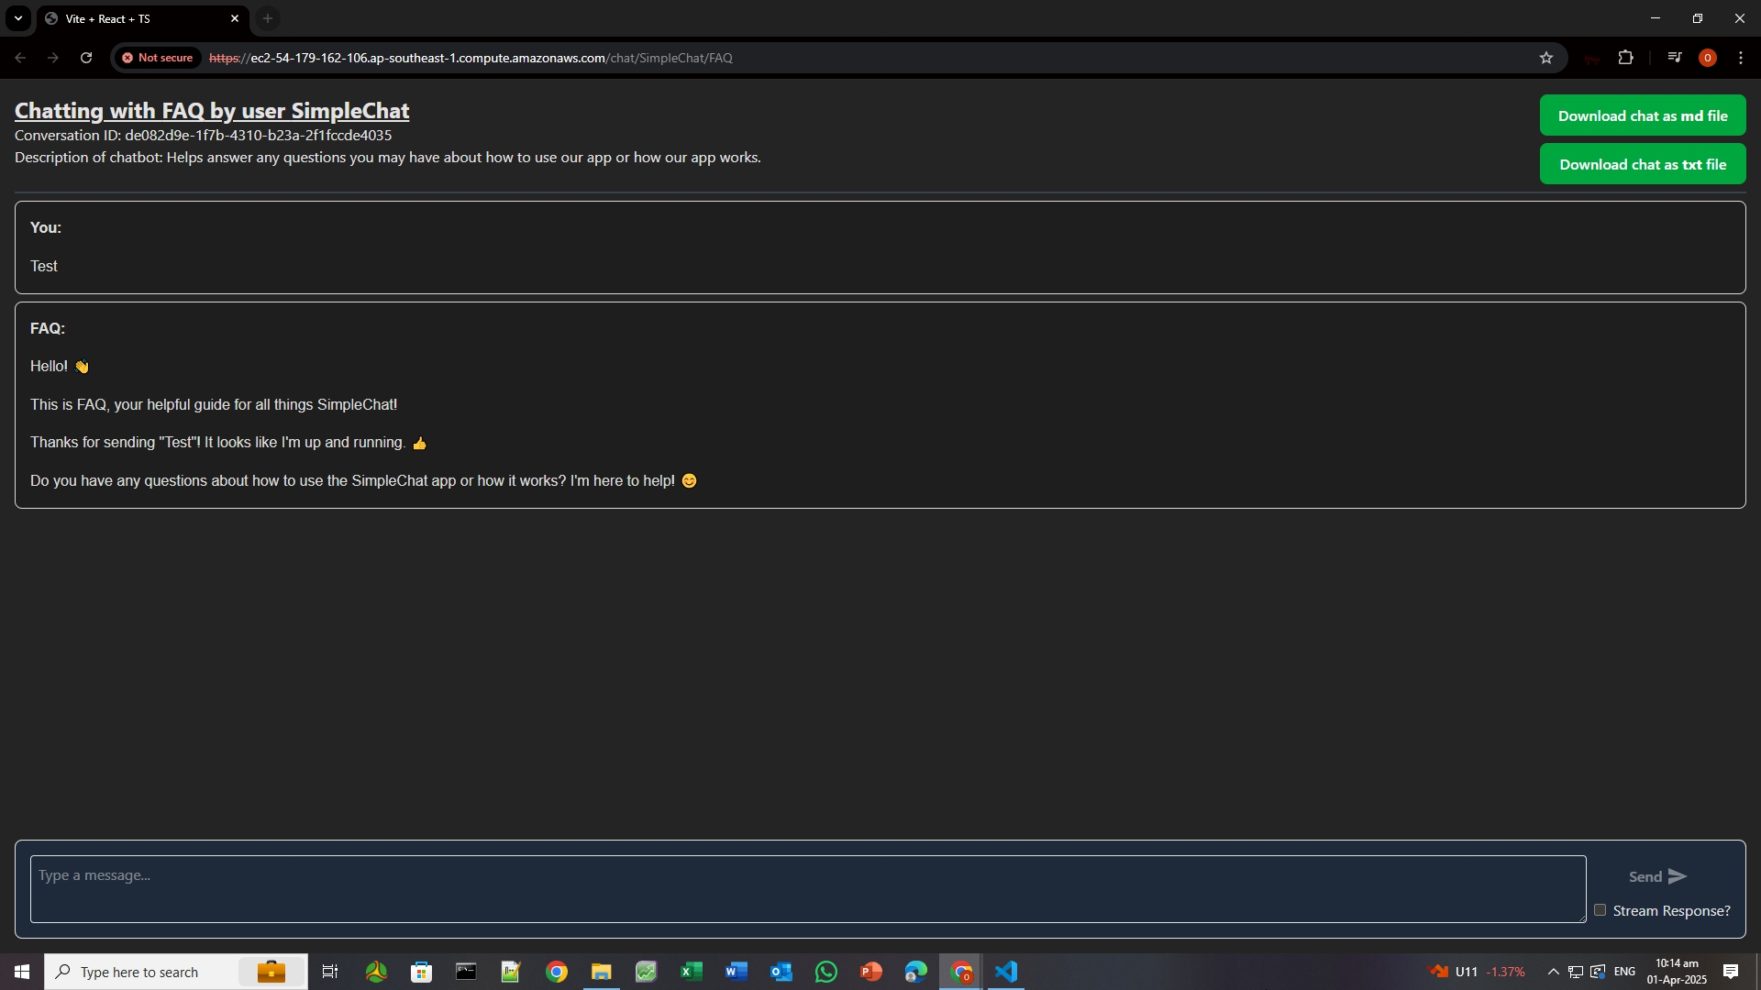

There is an option at the bottom right of the screen “Stream Response?” to toggle between “standard” or “stream” mode

* Standard: The chatbot will process the inputs before returning a complete response to you.
* Stream: The chatbot will process the inputs but start returning partial responses as soon as possible.

There is no difference in the output other than being able to start seeing a response sooner in “stream” mode.

**Note** that

* You will not be able to return to your conversation if you leave this page.
* You may choose to download your conversation in a text file or markdown file using the buttons on the top right if you wish.

# 5. Troubleshooting & FAQs

## Q1: I can't log in. What should I do?

If you forgot your password, please create a new account as there is no option to reset your password currently.

Otherwise please try the options below:

1. Ensure that your username and password are correct.
2. Try clearing your browser cache and cookies.

## Q2: My chatbot responses are incorrect. How can I fix this?

Chatbots may be inaccurate at times. This can be mitigated via fine tuning (adjusting) the inputs.

You can also try the following:

1. Check if the chatbot context settings are configured properly.
2. Ensure you have uploaded the correct reference files.
3. You may find that smaller and more specific context inputs or files is more effective.

After making any changes, try refreshing the page and restarting the conversation on a clean slate.

For more tips, please see “Tips for success” under section “3.1 Creating your own Chatbot”.

## Q3: Why can’t my chatbot generate images?

Unfortunately, the AI provider that we are using does not support this functionality yet. Thus chatbots will not be able to generate images.

## Q4: Why did my chatbot suddenly stop responding?

We are currently making use of Google Gemini API free tier. As such, if the other troubleshooting methods do not work, it is likely due to the rate limits imposed (Please refer to <https://ai.google.dev/gemini-api/docs/rate-limits> if you are curious to find out more).

Please try again later once the rate limits are lifted. Otherwise, you can refer to <https://github.com/Owen-Choh/SC4052-Cloud-Computing-Project> to see how you can run or host the project yourself.

## Q5: How do I delete my account?

Currently, there is no option to delete your account.

You may choose to delete your chatbots if you wish to remove any information provided to the chatbot from our app.

All data provided to the chatbot will be permanently removed upon confirming the deletion.

## Q6: Why is my file upload failing?

1. Check if your file size exceeds the size limit (10MB).
2. Ensure the file format is supported (e.g., .pdf, .jpg, .jpeg).

If these are correct, please try creating a new chatbot as there may be an unknown error.

## Q7: How do I reset the chatbot conversation?

Please refresh the page to start a new session.

## Q8: My account or chatbot disappeared?

Please try clearing your browser's cache and cookies and refresh the page to see if it reappears.

If your account or chatbot has disappeared, it may be due to extended periods of inactivity.

To keep our app free, we may need to clear inactive accounts or chatbots.

If you still require our services, do feel free to create a new account or chatbot.

# 6. FAQ Support Chatbot

If you have any questions please feel free to click on the “Click here” button at the login page.



It will direct you to our friendly chatbot to help answer your questions and guide you through how to use our app.

1. Updated as of 1 April 2025